Table of Contents

1 Objective 2

2 Data Source 2

3 Prerequisites Processes 2

3.1 Sales Import Data 2

4 Sales Report 3

4.1 Calling Program 3

4.2 Main Interface 4

4.2.1 Sales Report By Customer 4

4.2.2 Sales Report by Customer BU 5

4.2.3 Sales Report by Salesmen 6

4.3 Interface Description 6

5 Result 7

# Objective

To give a effective tools for sales team to monitor those key accounts. More fast and easy to find out the problem and timely take necessary actions.

# Data Source

Data source coming from I-Finance extraction. The report function located in Report Section – Sales Report. User can extract the report by fill in the date range and Customer information.

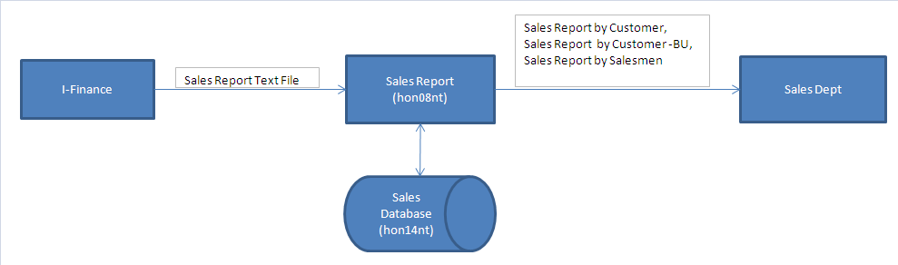

# Prerequisites Processes

## Sales Import Data

Sales Report > Data > Import Data

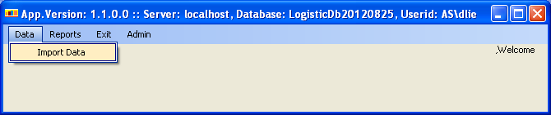

Import Data Interface

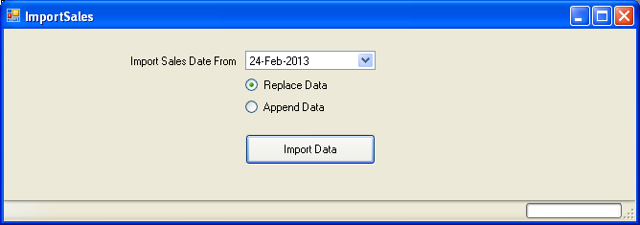

Steps:

1. Select import starting date from DateTime selection.
2. Replace Data: Remove existing data based on Selection date then data will be added based on your text file.
3. Append Data : Data will be added based on your text file.
4. Click Import Data button to start the process.
5. Locate your text file.

# Sales Report

## Calling Program

Sales Report > Reports > Sales Report

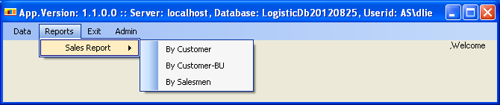

## Main Interface

### Sales Report By Customer

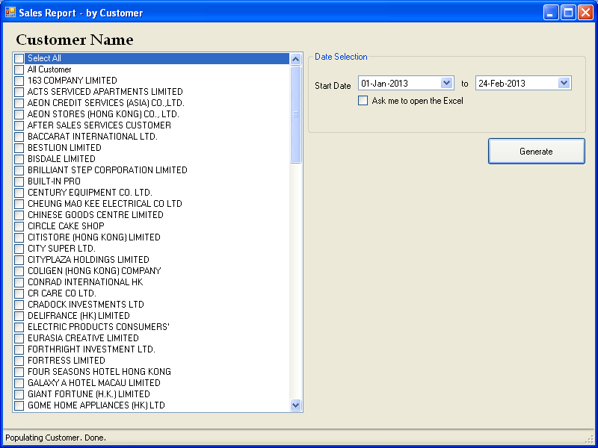

### Sales Report by Customer BU

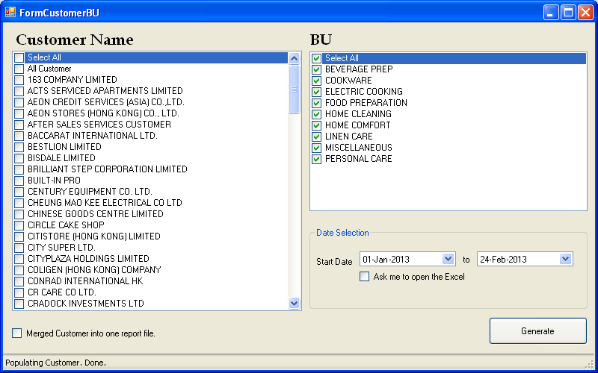

### Sales Report by Salesmen

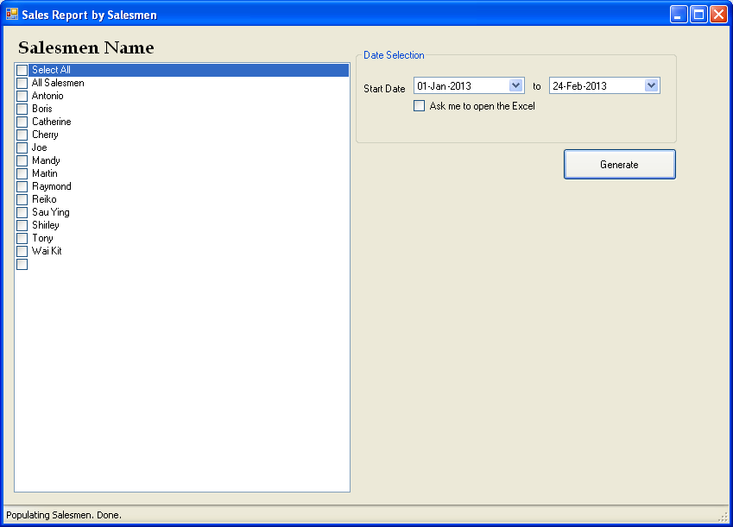

## Interface Description

1. Select one or many (Customer name , Salesmen , BU) from Selection List.
2. Select Report starting date and end date.
3. Click ask me to open the Excel if you want to see the report result.
4. Click Generate to process the report.
5. Select Folder location for report result.
6. Done.

# Result

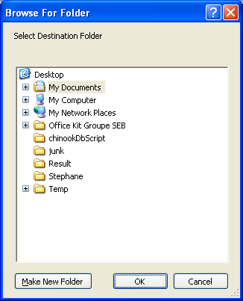

Select destination folder for report result.

